2. Database Schema

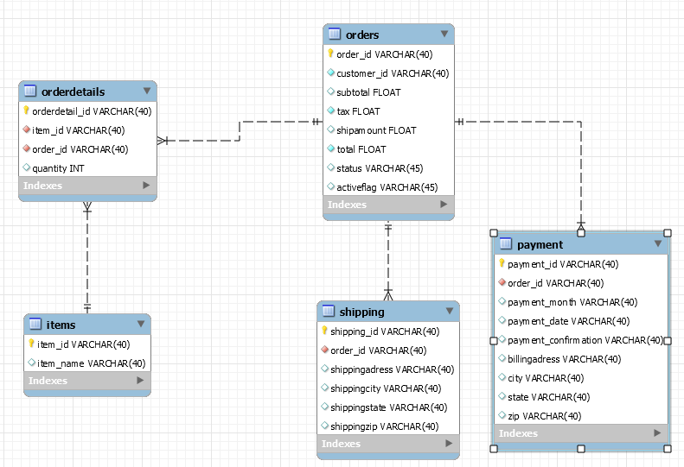

Initial Database state:

Order
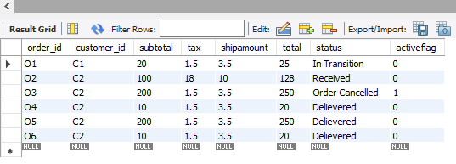

Orderdetails
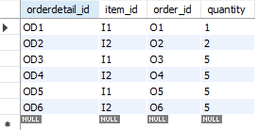

Items
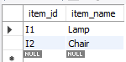

Payment
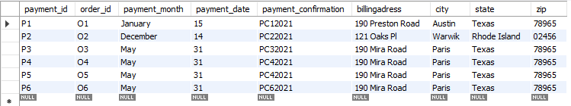

Shipping
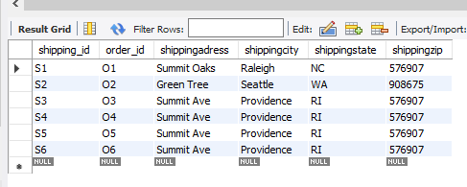

3. MicroServices- RESTful API

- RESTful clients that work with single order objects

i) get order by id

API URL: https://localhost:44334/api/GetOrderByID/O1

Postman API Testing
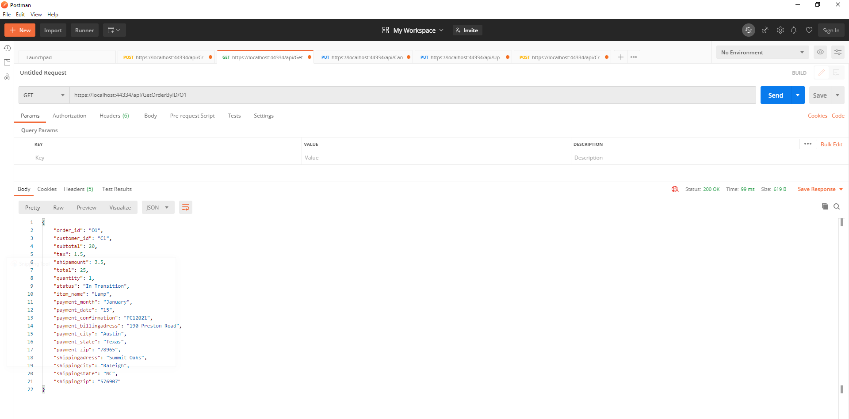

ii) create an order

API URL: https://localhost:44334/api/CreateOrder/O6

Postman API Testing:
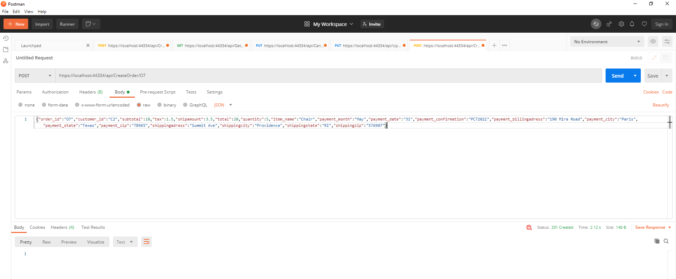

Database Screenshot:

Order
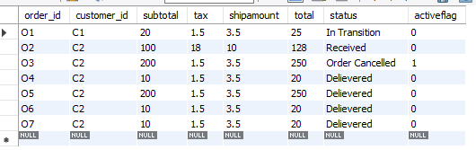

Orderdetails
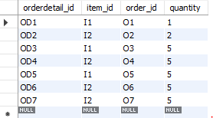

Payment
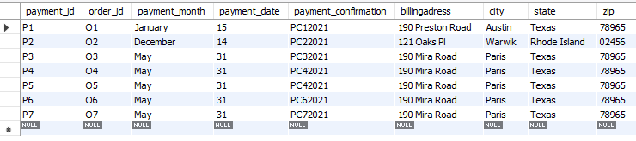

Shipping
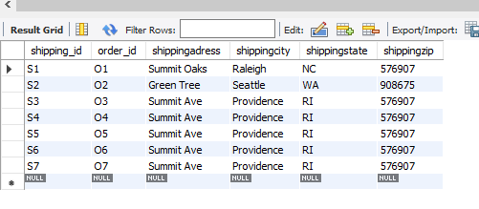

iii) Cancel an order

API URL: https://localhost:44334/api/CancelOrder/{id}

Postman API Testing:
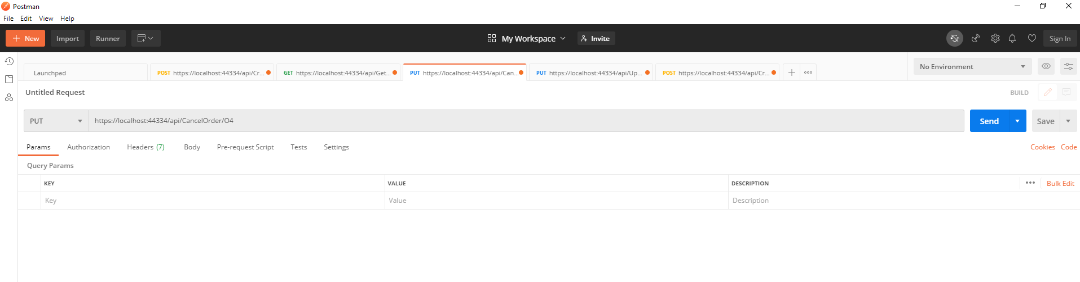

Database Screenshot:

order
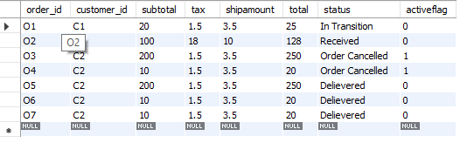

- Clients that work with bulk order objects

i) create orders in bulk/batch

API URL: https://localhost:44334/api/CreateOrder/

Postman API Testing:
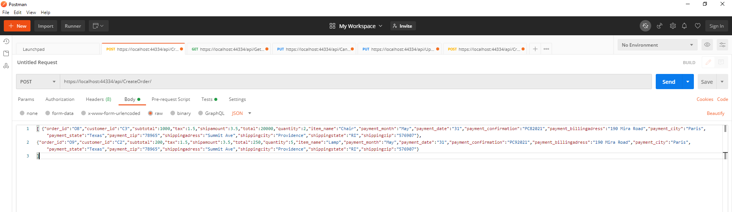

Database Screenshot:

order
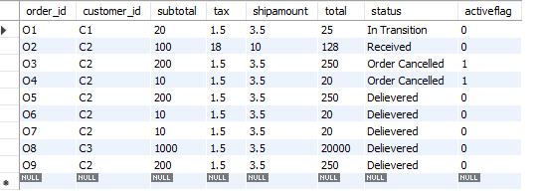

Orderdetails
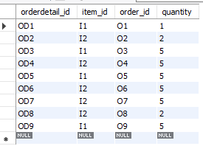

Payment
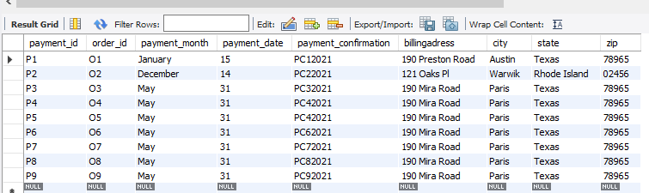

Shipping
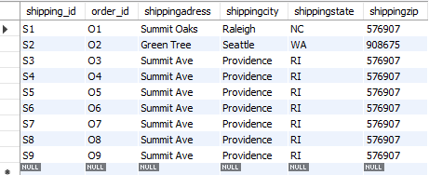
ii) update order status in bulk/batch

API URL:https://localhost:44334/api/UpdateOrderStatus

Postman API Testing:
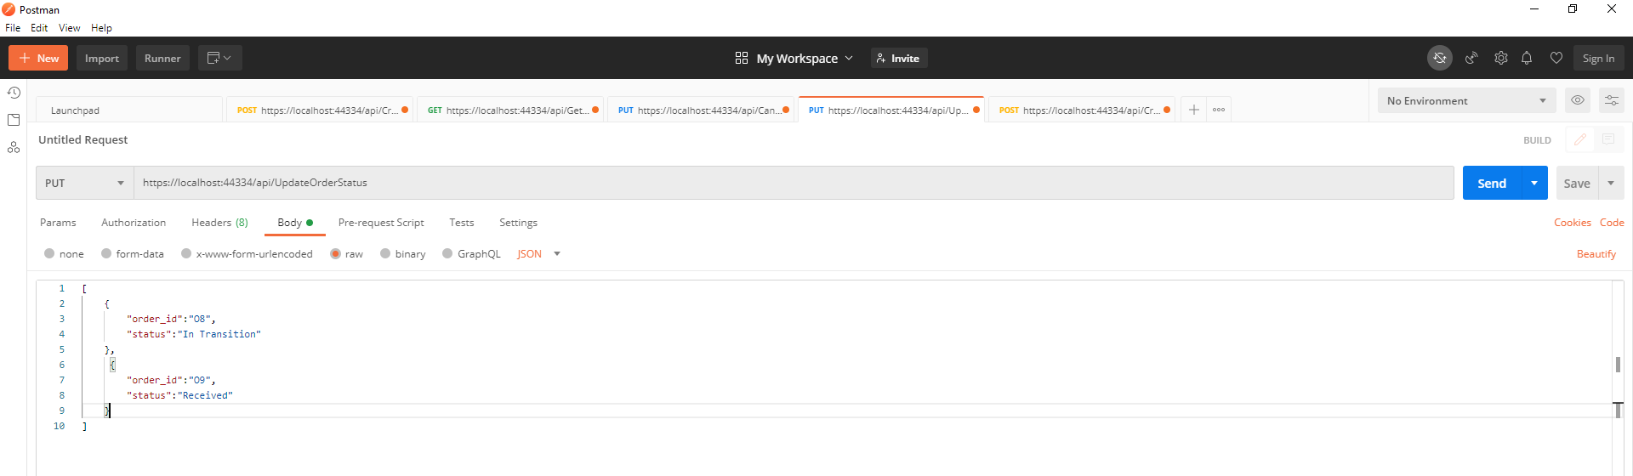

Database Schema:

Order
